# **An exploration of Apache Giraph**

**1. Introduction**

In recent years, network analysis was growing rapidly with many applications in terms of social networks, transportation systems or power grids, which played an important role in our daily life and the infrastructure of a country. Leveraging social networks will offer the businesses an ideal opportunity to increase their brand awareness, build their reputation, boost sales, and therefore improve profitability. Besides that, acknowledging and optimizing transportation network or power distribution system will help companies or countries to improve their efficiency and service quality, as well as to reduce their operating costs. To achieve that, it is essential to have a useful network analysis tool, which allows the processing of large-scale graphs in a distributed fashion. In this project, we are going to introduce one of the most powerful analysis tools named Apache Giraph in terms of how it works and the benefits it provides in the context of network analysis.

## **Apache Giraph introduction**

Apache Giraph is an open-source platform developed by the implementation of Google’s Pregel for large-scale graph processing. Therefore, Giraph is also called Pregel-like system. Both Apache Giraph and Pregel are parallel graph processing frameworks, which provide a vertex-centric programming model. However, Giraph offers some better features than basic Pregel in terms of fault tolerance improvement, master computation and dynamic graph topology support (Apache Software Foundation, 2020).

Apache Giraph is built on top of the Apache Hadoop infrastructure which runs graph processing jobs using HDFS and ZooKeeper for data input and output, coordination, checkpointing, and recovery methods (Batarfi, O. et al., 2015) and Java language.

## **Apache Giraph features**

The are some main features Apache Giraph provides which make it become a powerful tool for large-scale graph processing, including:

Vertex-centric programming model: in Giraph framework, graph computations are defined at the individual vertex level, transmitted through edges, and executed in parallel across the entire graph (Han, M. et al., 2014, Batarfi, O. et al., 2015).

High scalability: Giraph offers fast and scalable processing by utilizing distributed computing clusters, which means that additional computers can be added to distributed systems easily, and its performance is optimized by tuning its configurations (Koch, J. et al., 2016).

Fault tolerance: Giraph can identify node failures by setting a local converged flag and using global aggregation. Then, it can handle the failed nodes by providing automatic restart and recovery (Koch, J. et al., 2016).

Flexibility: Giraph supports the dynamic addition or removal of vertices and edges during graph processing, leading to space efficiency and loading time improvement. Hence, Giraph can enable real-time graph analytics (Han, M. et al., 2014).

## **Apache Giraph tasks**

Apache Giraph can be used for a variety of graph processing tasks in terms of social network analysis, PageRank and web analytics, or network analysis.

For social network analysis, Giraph is widely used by Facebook or LinkedIn as a powerful and effective tool. Giraph can be applied to analyze social network graphs and perform tasks such as popularity or personalized ranking calculation, shared connections determination, community detection, and advertisement propagation for their active users (Han, M. et al., 2014).

Regarding PageRank and web analytics, Giraph can be used to analyze web graphs and perform website ranking task by applying PageRank computation, hyperlink analysis, and web search optimization (Koch, J. et al., 2016).

Besides that, Giraph can also be used for various types of network analysis, such as transportation networks to determine the traffic flow, or biological networks to understand protein interactions and pathological anomalies detection (Han, M. et al., 2014), which greatly contribute to the healthcare sector.

Although Apache Giraph is beneficial to many aspects, the scope of this project is to bring an exploration of how Giraph could work for network analysis by applying Giraph to solve the travelling salesman problem (TSP). From the TSP, we can explore various applications which benefit for many fields such as planning, logistics, material science, biology, or astronomy.

# **2. Methodology**

# **Tools needed for Giraph and Installation Procedure**

## **2.1 Java Installation**

First, install java jdk from Oracle.com for macOS as shown below using the link -

<https://www.oracle.com/ca-en/java/technologies/downloads/#java8-mac>

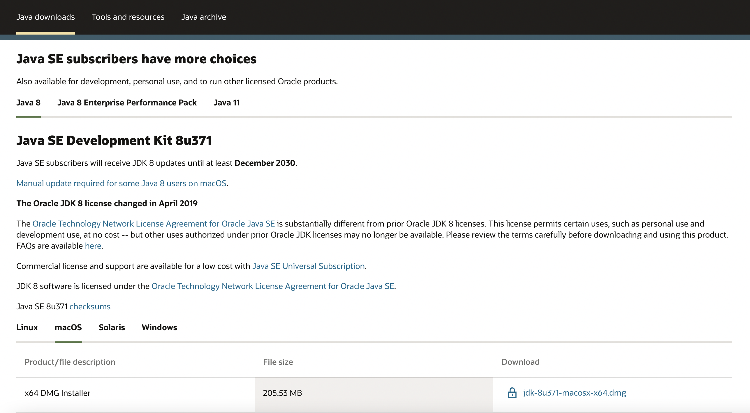

## **2.2 Hadoop Installation and configuration parameters**

Then we need to install Hadoop 1.2.1 using Apache Hadoop archive website below -

<https://archive.apache.org/dist/hadoop/core/hadoop-1.2.1/hadoop-1.2.1.tar.gz>

Then, we set the bashrc and zshrc files to point towards the right Hadoop directory

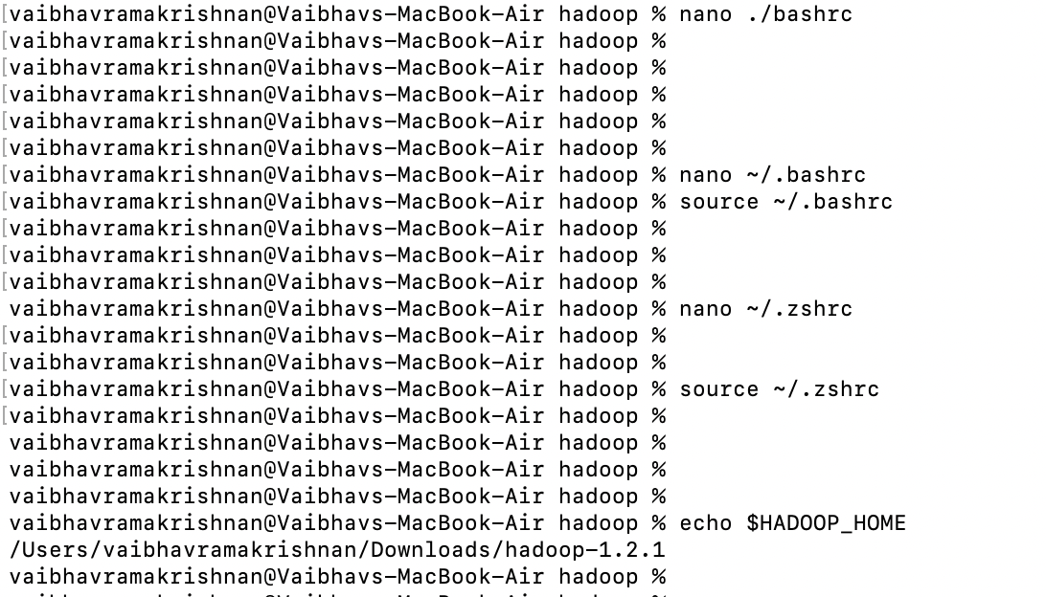

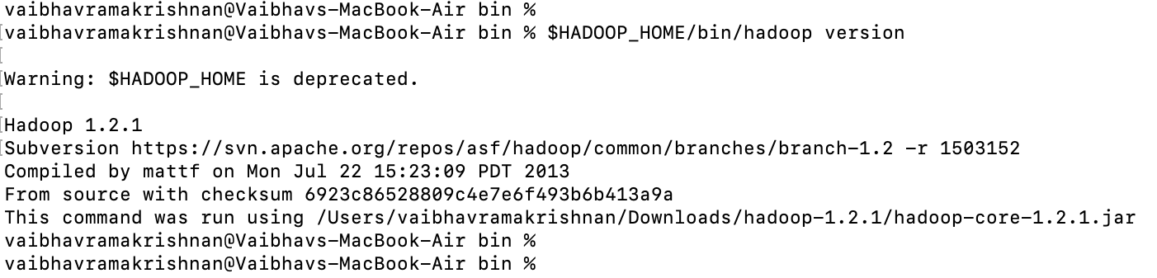

Also, update the Hadoop-env.sh to point towards the right Java version by updating the path of **$JAVA_HOME**.

Below screenshot shows that we have successfully updated the Hadoop-env.sh file as the Java version is rightly showing to be 1.8.

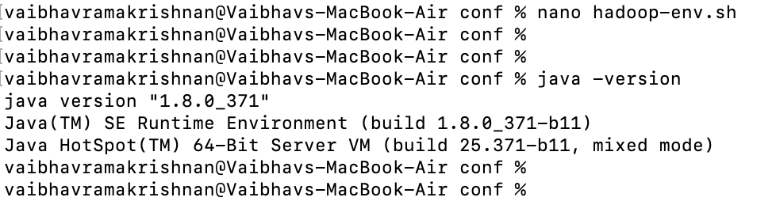

After this, we start the namenode using command **bin/Hadoop namenode -format** from the Hadoop home directory.

The below screenshot shows the successful execution of the command.

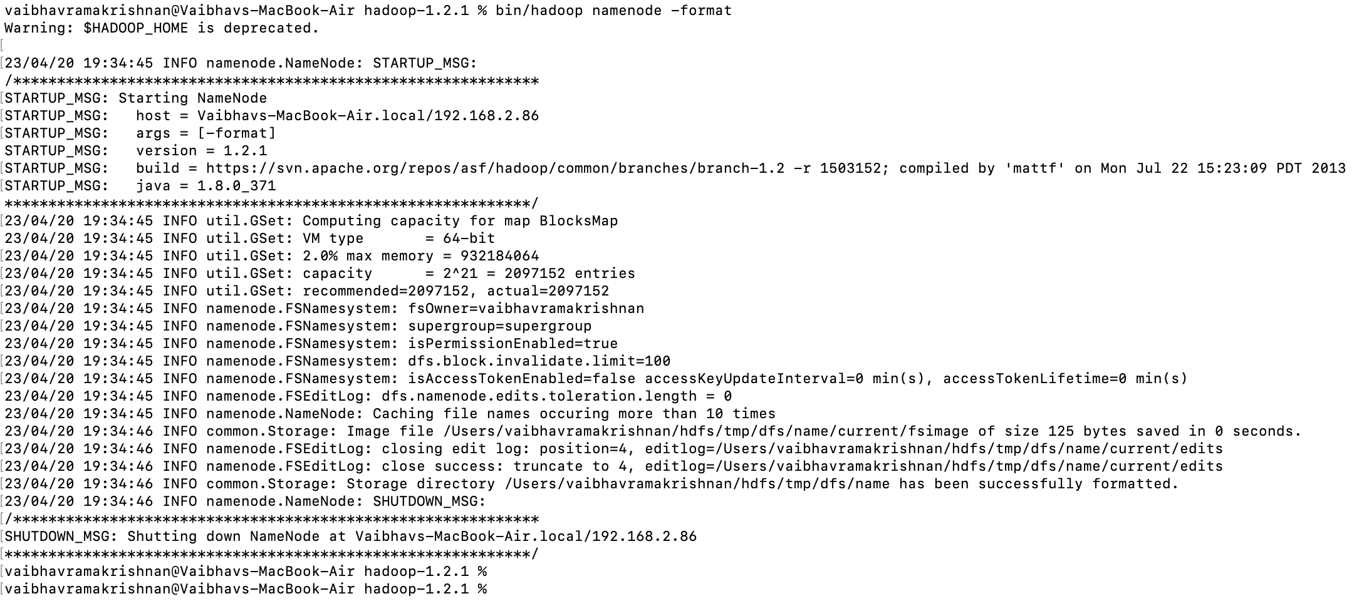

Then we start the HDFS daemons using command **bin/start-dfs.sh** as shown below.

This will help start namenode, secondary namenode and datanode.

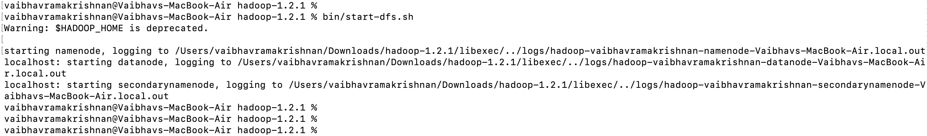

**bin/start-mapred.s**h will start the MapReduce daemons - JobTracker and TaskTracker.

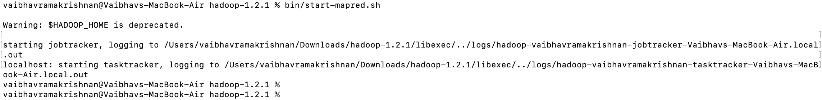

**NameNode**

It is the master node and controls the HDFS (Hadoop Distributed File Cluster) metadata.

**JobTracker**

It serves as the master node in the Hadoop MapReduce framework.

This aids in the processing of huge datasets.

It receives client job requests and schedules jobs to run on the cluster.

It monitors the progress of the assigned task.

**TaskTracker**

It, like JobTracker, is a component of the Hadoop MapReduce system. It is in charge of carrying out the tasks assigned to it by JobTracker.

TaskTracker is thus a slave node in the MapReduce system.

TaskTracker updates JobTracker on the status of its tasks and requests new tasks as soon as they become available.

**DataNode**

It is a slave node that stores data in HDFS.

**SecondaryNameNode**

It is an HDFS helper node.

It aids in reducing the time required for NameNode to recover from a failure.

It is not a backup or failover node, but rather aids in reducing the time required to recover from a failure.

SecondaryNameNode gets the current state of NameNode's file system metadata and transaction logs on a regular basis.

The jps command shown below helps display the Java Virtual Machines (JVMs) that are running on each node in the Hadoop cluster.

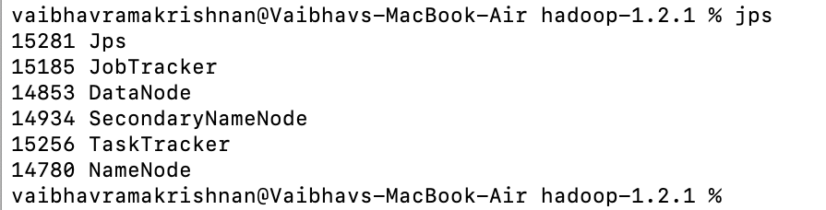

**2.3 Building and Installing Apache Giraph**

First install maven using brew install maven on macOS as shown below.

Maven is a popular automation tool in the Java environment for managing dependencies and building projects. It is used to manage project dependencies and build Giraph artefacts in the case of Apache Giraph. Overall, Maven ensures that the project may be simply produced and deployed across several environments.

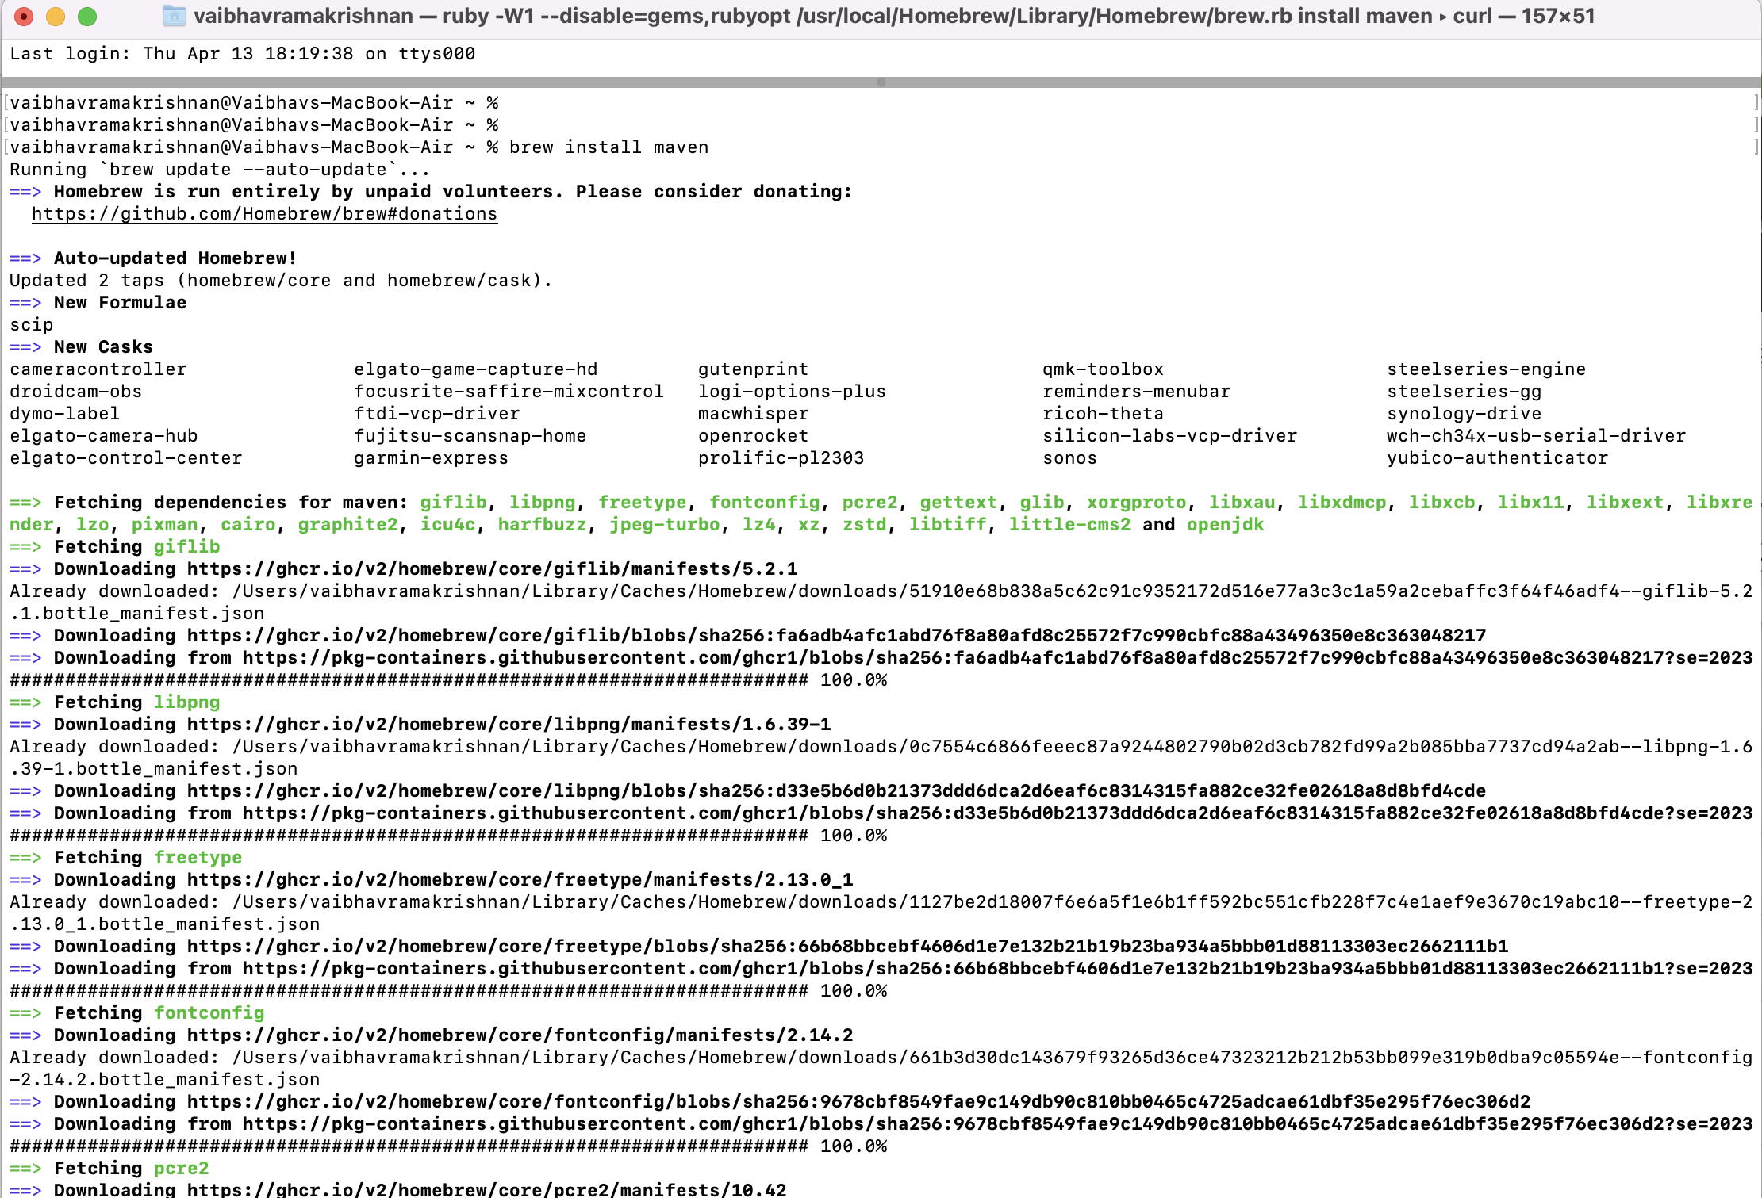

Pull the most recent giraph from the github repository by cloning it using git as shown below

**git clone https://github.com/apache/giraph.git**

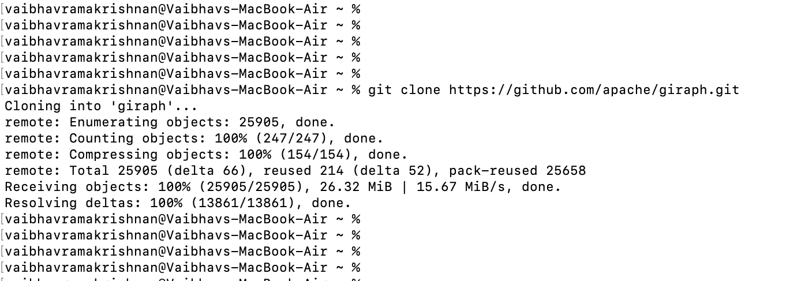

Once done, go to the giraph directory (**cd giraph**).

Run the command **mvn package -DskipTests** inside the giraph directory.

It essentially bundles our project's source code into a distributable manner while skipping the tests throughout the build process. This guarantees that we can immediately deploy the project without having to wait for all of the tests to finish.

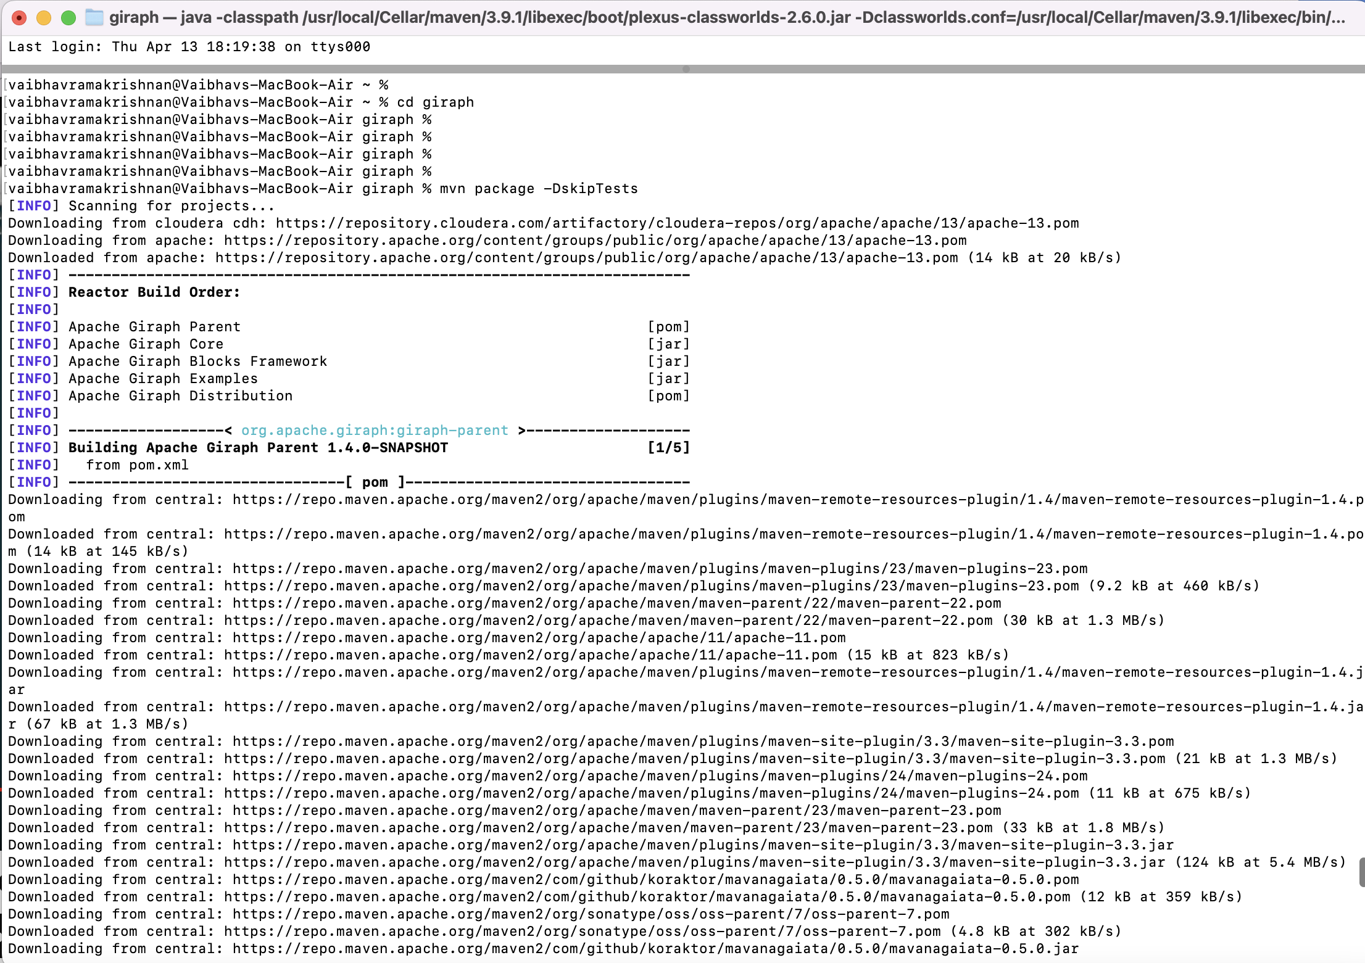

The screenshot below shows the command was successfully executed and we were successfully able to build Giraph.

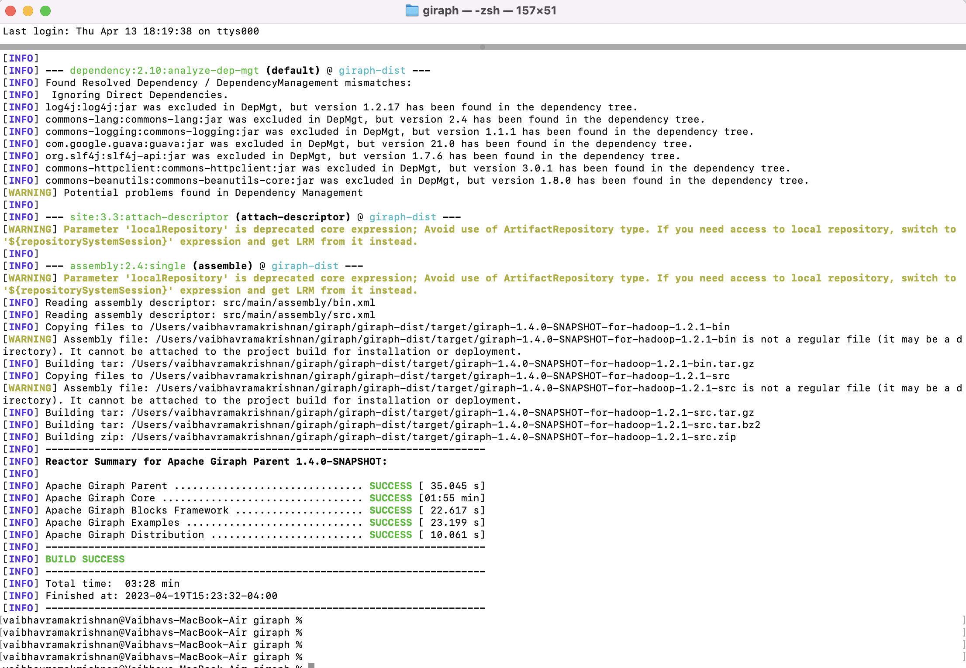

# **3. Travelling Salesman Problem (TSP)**

To illustrate how Apache Giraph works, we have implemented the Travelling Salesman Problem (TSP).

The objective of TSP is to determine the most efficient route that visits multiple cities exactly once and returns to the starting city, which is called Hamiltonian cycle, thereby minimizing the total distance travelled.

The Graph models in Giraph helps us model the TSP.

1. Because the edges are oriented, the distance from city A to city B may differ from the distance from city B to city A.
2. The vertexes' values are also considered, which means that going through a city will increase the distance.

## **3.1 Concepts behind the Implementation on Apache Giraph**

We must model the TSP as a Graph in order to implement it in Giraph.

Each city is denoted by a vertex.

The distances between cities are represented by the edges.

Because the edges are directed and distances can be unequal, we must describe the TSP issue using a weighted directed graph.

This entails doing many super steps, which entails delivering messages between graph vertices.

The image below depicts a graph with uneven edges that connects cities.

Giraph will compute the active nodes at each super step.

This active node/city/vertex will send a message to the remaining "cities" to test all feasible pathways. The notification will include the current path length as well as the path travelled thus far. 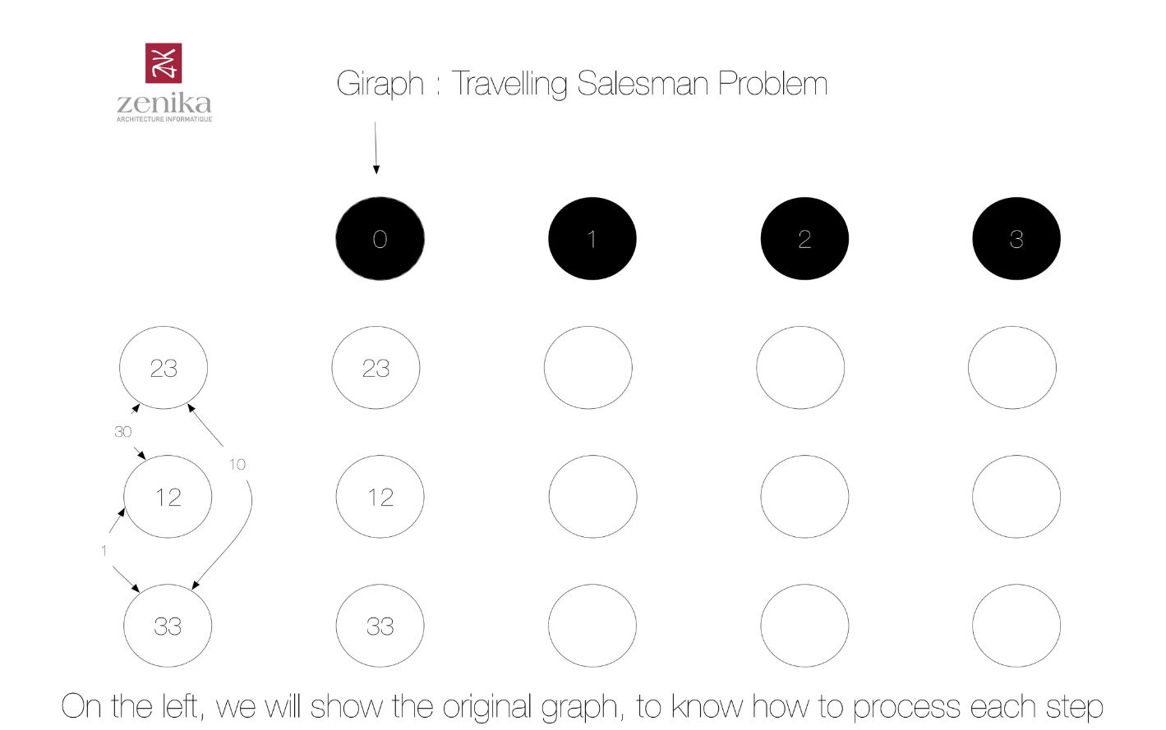

The source node/vertex (or starting city) accumulates all distances and chooses the shortest distance, as shown below -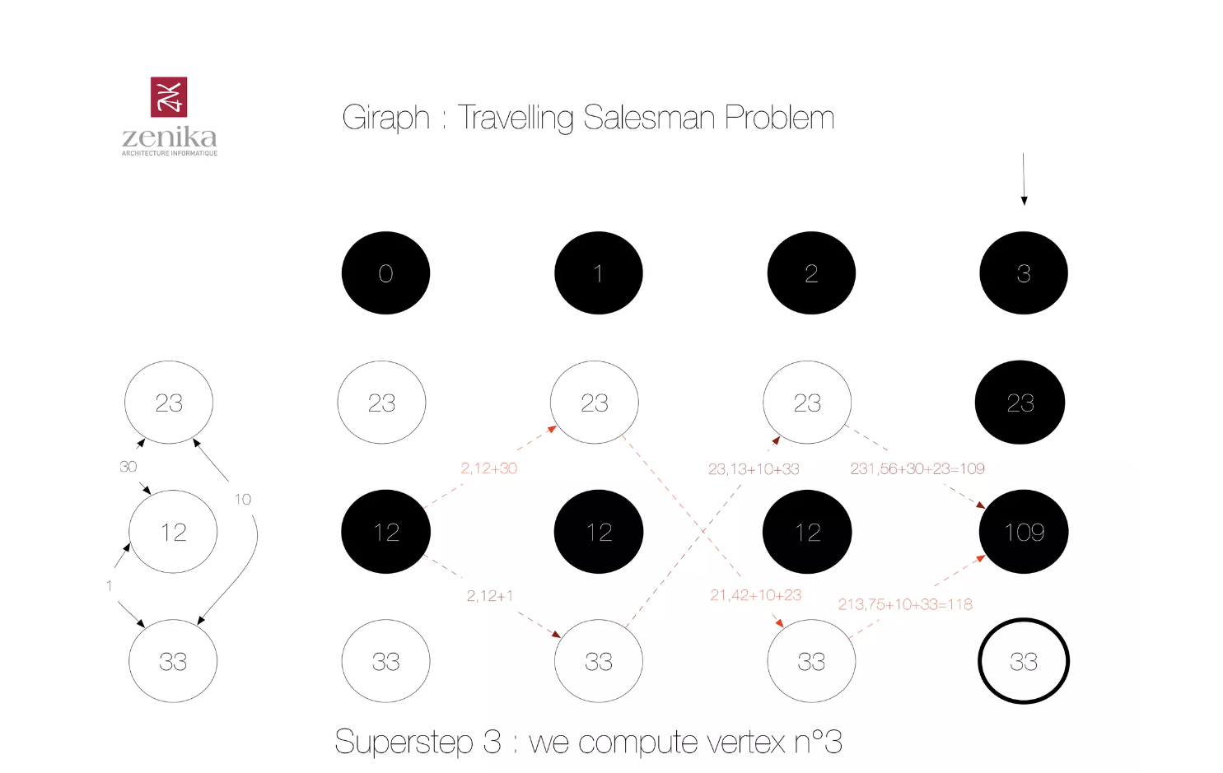

Overall, Giraph assists us in providing a flexible and scalable framework for addressing complicated problems such as TSP, as seen above. Because Giraph is capable of distributed processing, it can assist in the resolution of issues involving a large number of cities and complex edge weights.

## **3.2 Implementing TSP Problem using Giraph from GitHub**

In order to solve the Travelling Salesman Problem (TSP) we need the implementation of the Giraph algorithm to solve this problem.

Apache Giraph employs Java programming language. For this, we found a TSP implementation on GitHub <https://github.com/edaboussi/Giraph>

“Giraph brute-force implementation of the Travelling Salesman Problem”

First off, we need the TSP.Java file.

This Java file offers the Giraph algorithm's implementation for solving this problem.

It establishes the network structure, assigns vertices starting values, and defines the logic for determining the shortest path.

The TSP problem is solved in a scalable and distributed manner by running this code on the Hadoop platform.

Copy the TS.java file to the **src** directory inside Giraph folder as shown below -

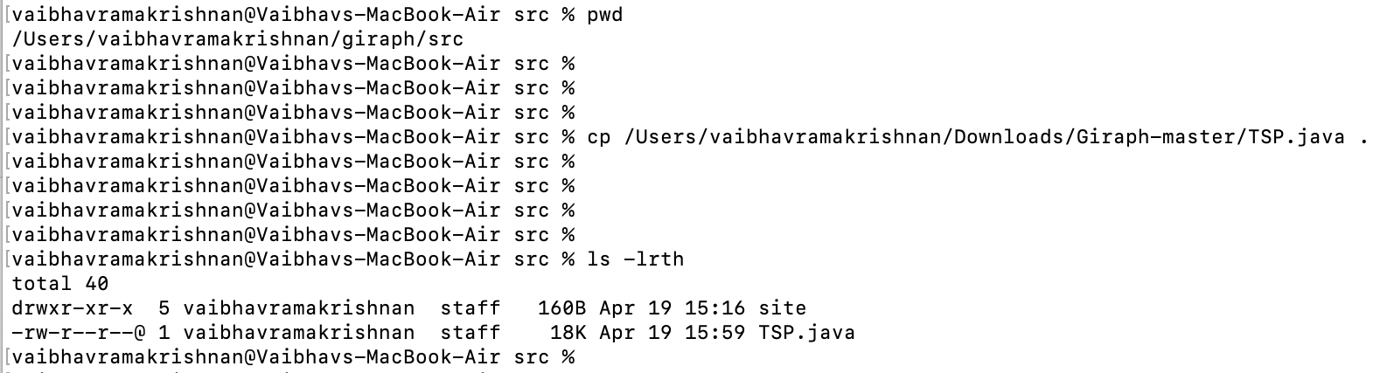

After adding the TSP.java file, we must use Maven to compile the Giraph project.

We used the mvn compile command, as seen below.

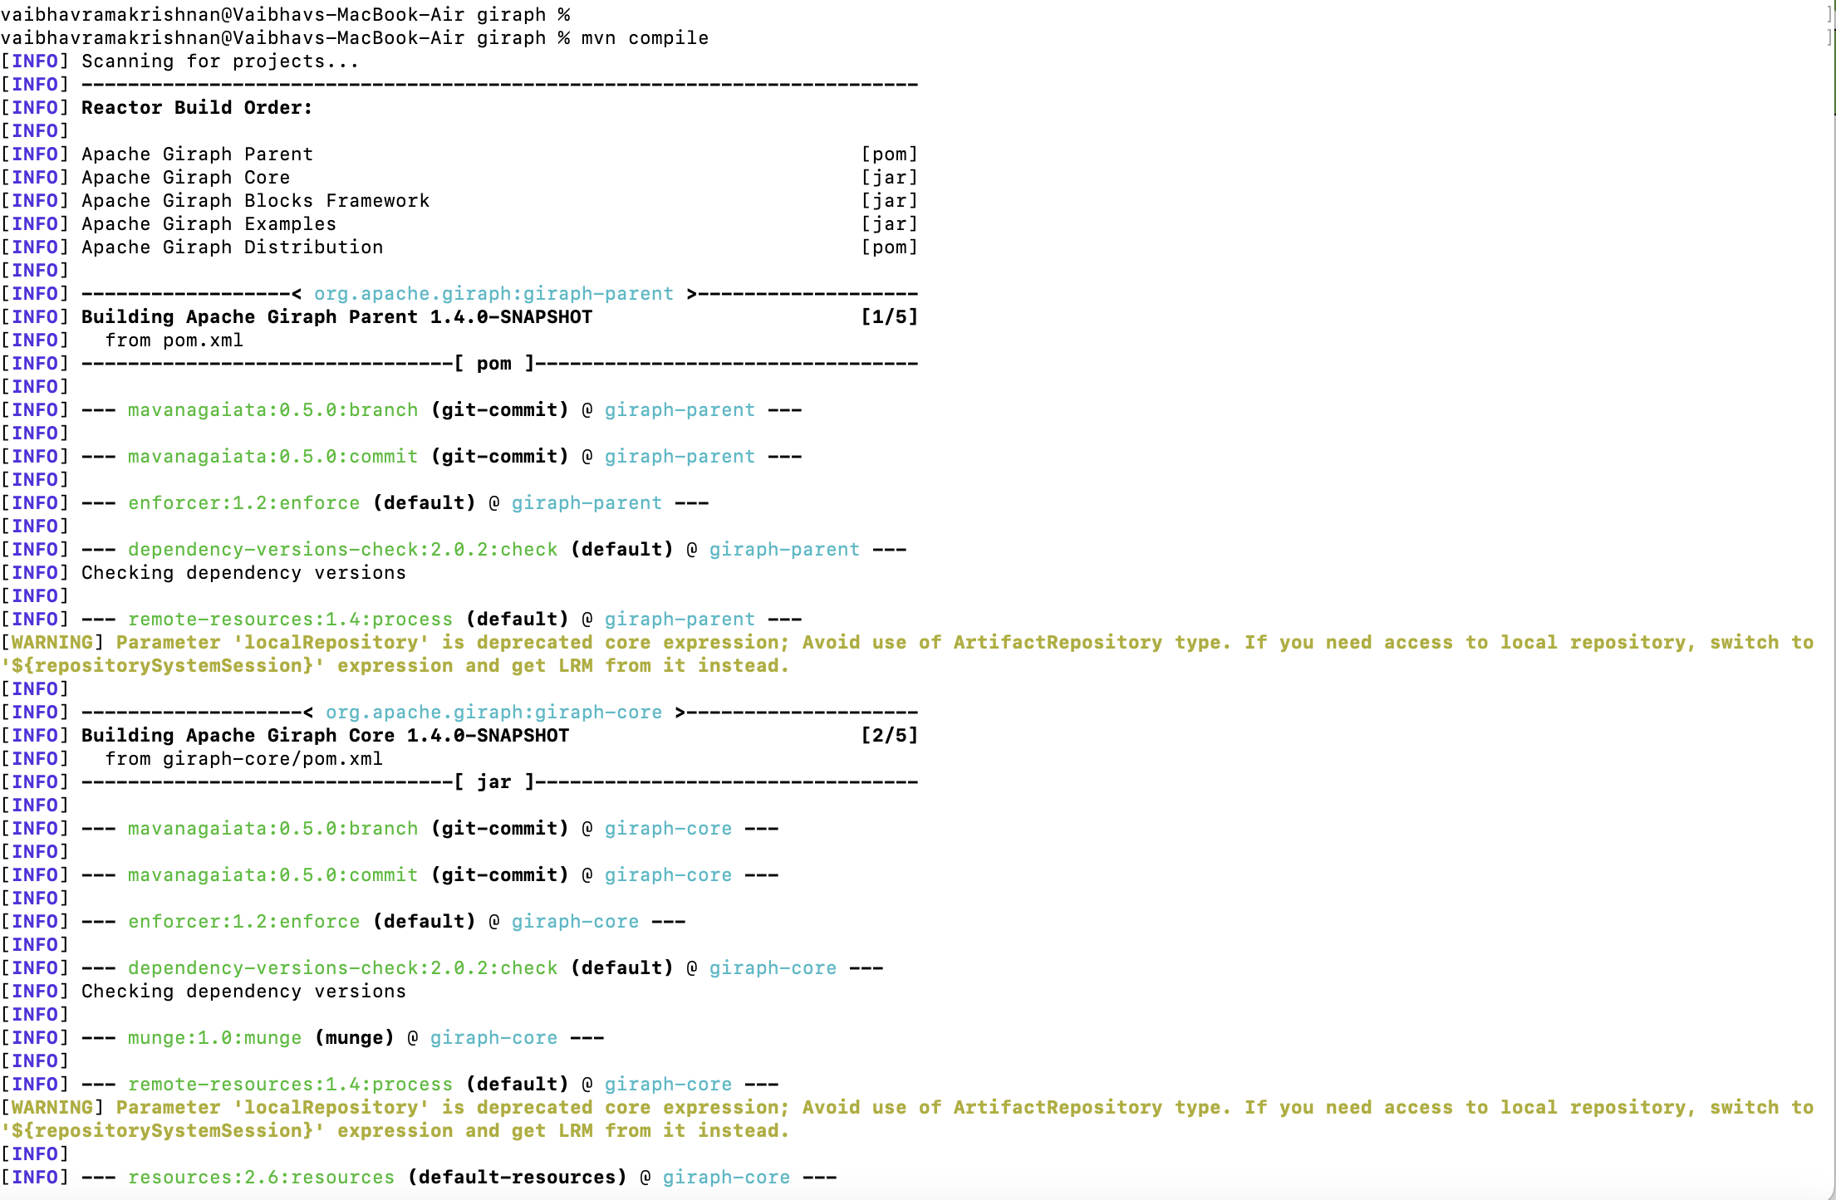

As shown below, the compilation was successful.

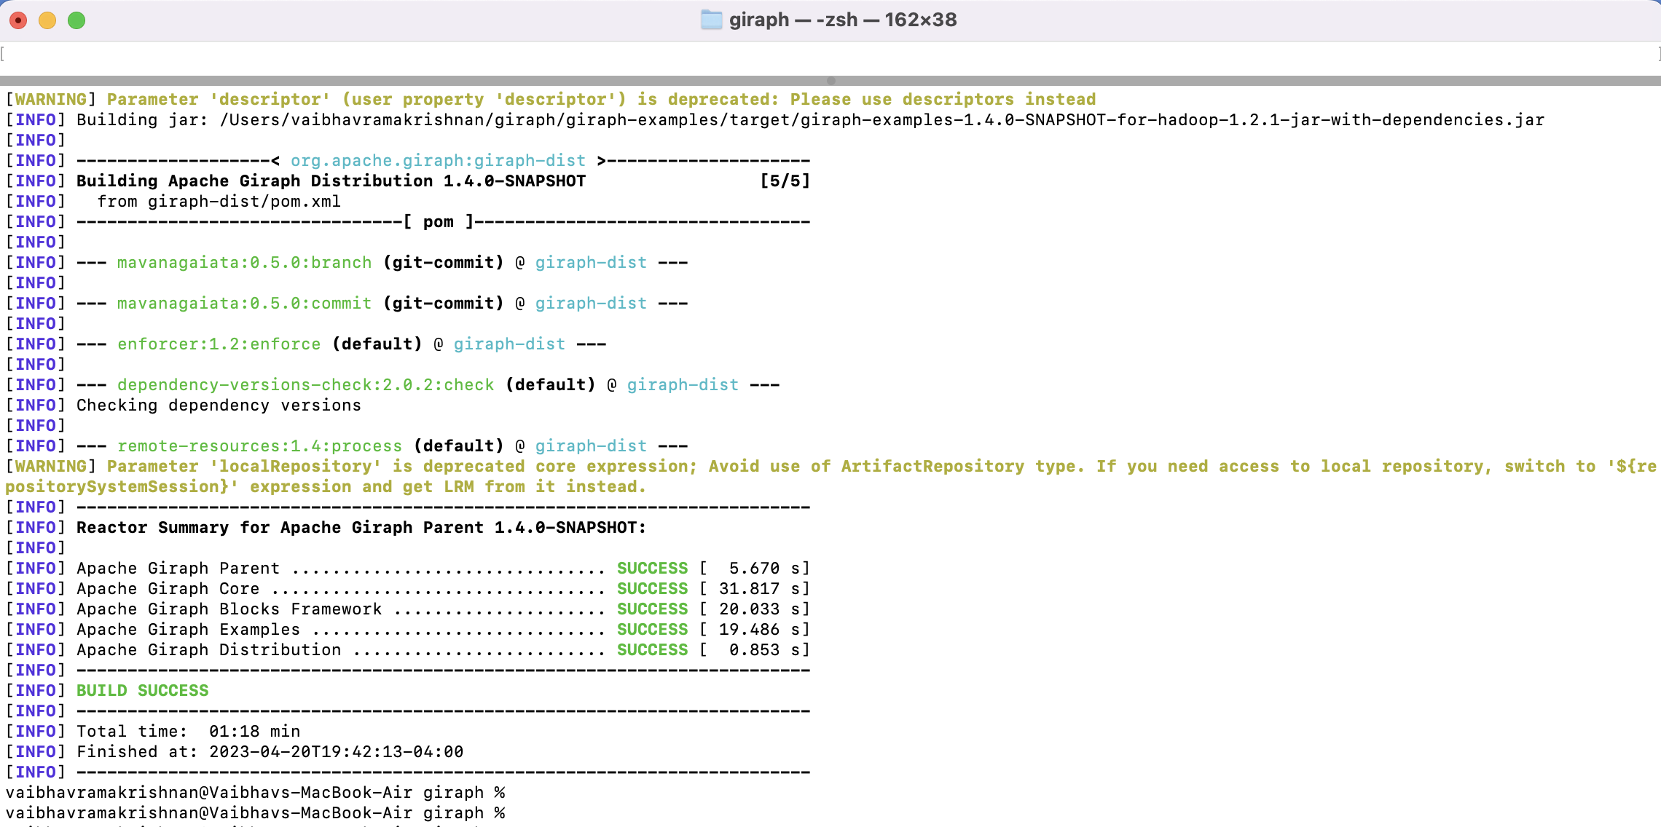

Once, this is done, we need to place the input file in HDFS using below command -

**$HADOOP_HOME/bin/hadoop fs -put /Users/vaibhavramakrishnan/Downloads/Giraph-master/tiny_graph /input**

The below screenshot shows we were successfully able to put the graph (tiny_graph) file inside the input directory.

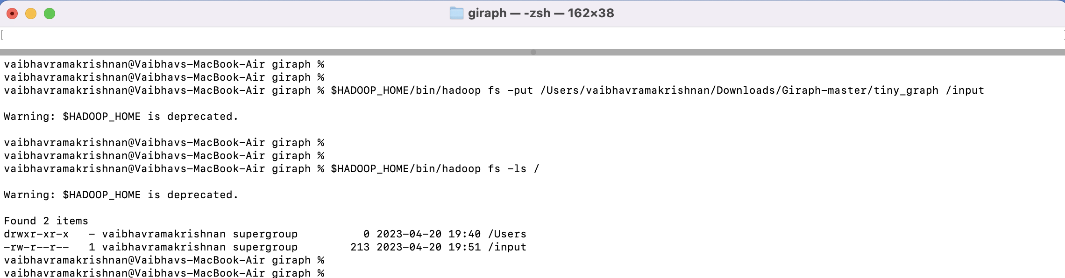

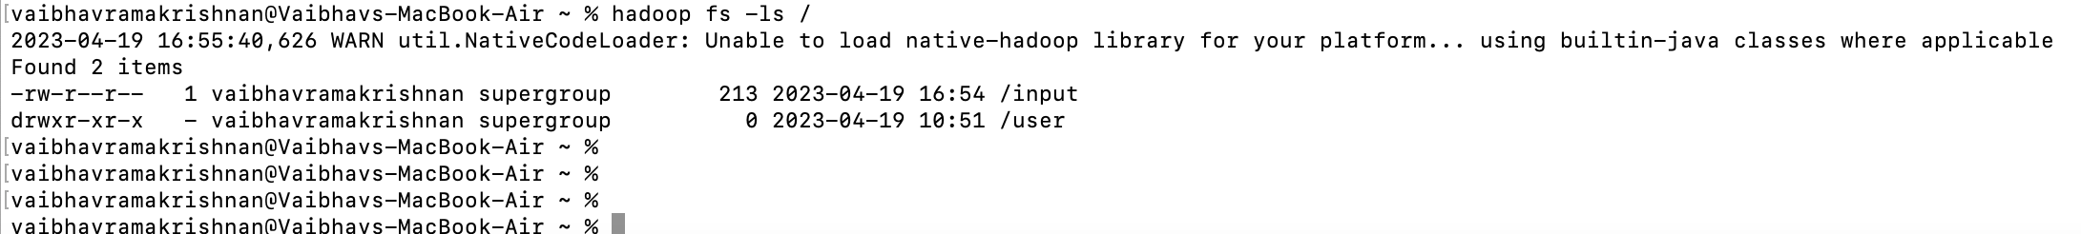

Now, we can see the contents of our input file using the command - **$HADOOP_HOME/bin/hadoop fs -cat /input**

This input file contains the graph expressed as a set of edges between vertices, each with its own weight or cost. This TSP seeks the shortest path possible that visits each city or vertex precisely once and returns to the starting vertex or city.

The below snapshot shows the contents of our input graph -

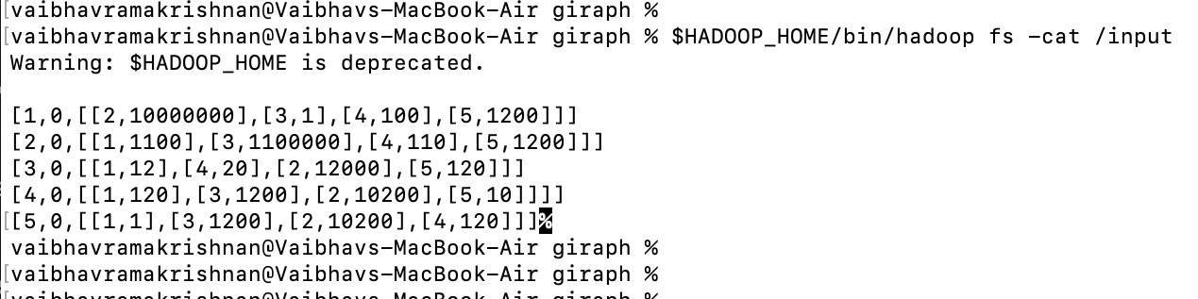

[1,0,[[2,10000000],[3,1],[4,100],[5,1200]]]

[2,0,[[1,1100],[3,1100000],[4,110],[5,1200]]]

[3,0,[[1,12],[4,20],[2,12000],[5,120]]]

[4,0,[[1,120],[3,1200],[2,10200],[5,10]]]]

[5,0,[[1,1],[3,1200],[2,10200],[4,120]]]**%**

In the above output, each line represents a vertex/node/city and its neighbours, in the format -

**[vertex_id, vertex_value, [list_of_neighbor_edges]]**

So, for instance, the first line [1,0,[[2,10000000],[3,1],[4,100],[5,1200]]] indicates that vertex 1 has a value of 0 and has four edges connecting it to its neighbours: 2 with a weight of 10000000, 3 with a weight of 1, 4 with a weight of 100, and 5 with a weight of 1200.

Similarly, for other nodes/cities through 2 to 5 with their respective neighbours and weights.

We use the **giraph-examples-1.4.0-SNAPSHOT-for-hadoop-1.2.1-jar-with-dependencies** to execute the Giraph jar (Java archive) with Hadoop.The Apache Giraph example code is contained as a jar file. This file contains all of the requirements that will be required to run the examples on a Hadoop cluster. This filename specifies the Apache Giraph example version and Hadoop version (1.2.1 in our case). This made it easier for us to execute the example on the Hadoop cluster without having to manually change dependencies.

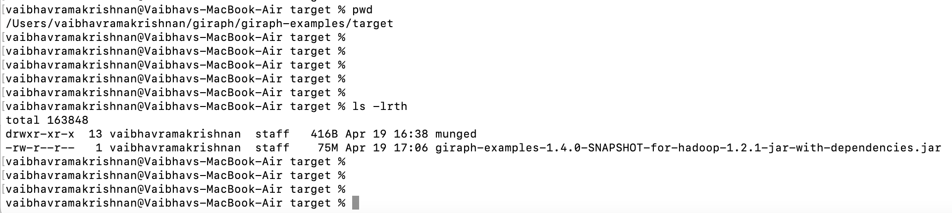

Finally, we run the Giraph jar with Hadoop using the command -

**$HADOOP_HOME/bin/hadoop jar $GIRAPH_HOME/giraph-examples/target/giraph-examples-1.4.0-SNAPSHOT-for-hadoop-1.2.1-jar-with-dependencies.jar org.apache.giraph.GiraphRunner org.apache.giraph.examples.SimpleShortestPathsComputation -vif org.apache.giraph.io.formats.JsonLongDoubleFloatDoubleVertexInputFormat -vip /input -vof org.apache.giraph.io.formats.IdWithValueTextOutputFormat -op /output -w 1**

This command helps us compute the ShortestPath algorithm. The input is in JSON format and output is in the form of vertex IDs and their values in text format.

The number of workers specified -w 1, means computation is done using a single worker.

The command specifies the input format (-vif) as **org.apache.giraph.io.formats.JsonLongDoubleFloatDoubleVertexInputFormat**, the input path (**-vip**) as /input, the output format **(-vof**) as **org.apache.giraph.io.formats.IdWithValueTextOutputFormat**, and the output path (**-op**) as /output.

The below snapshot shows successful execution of the command.

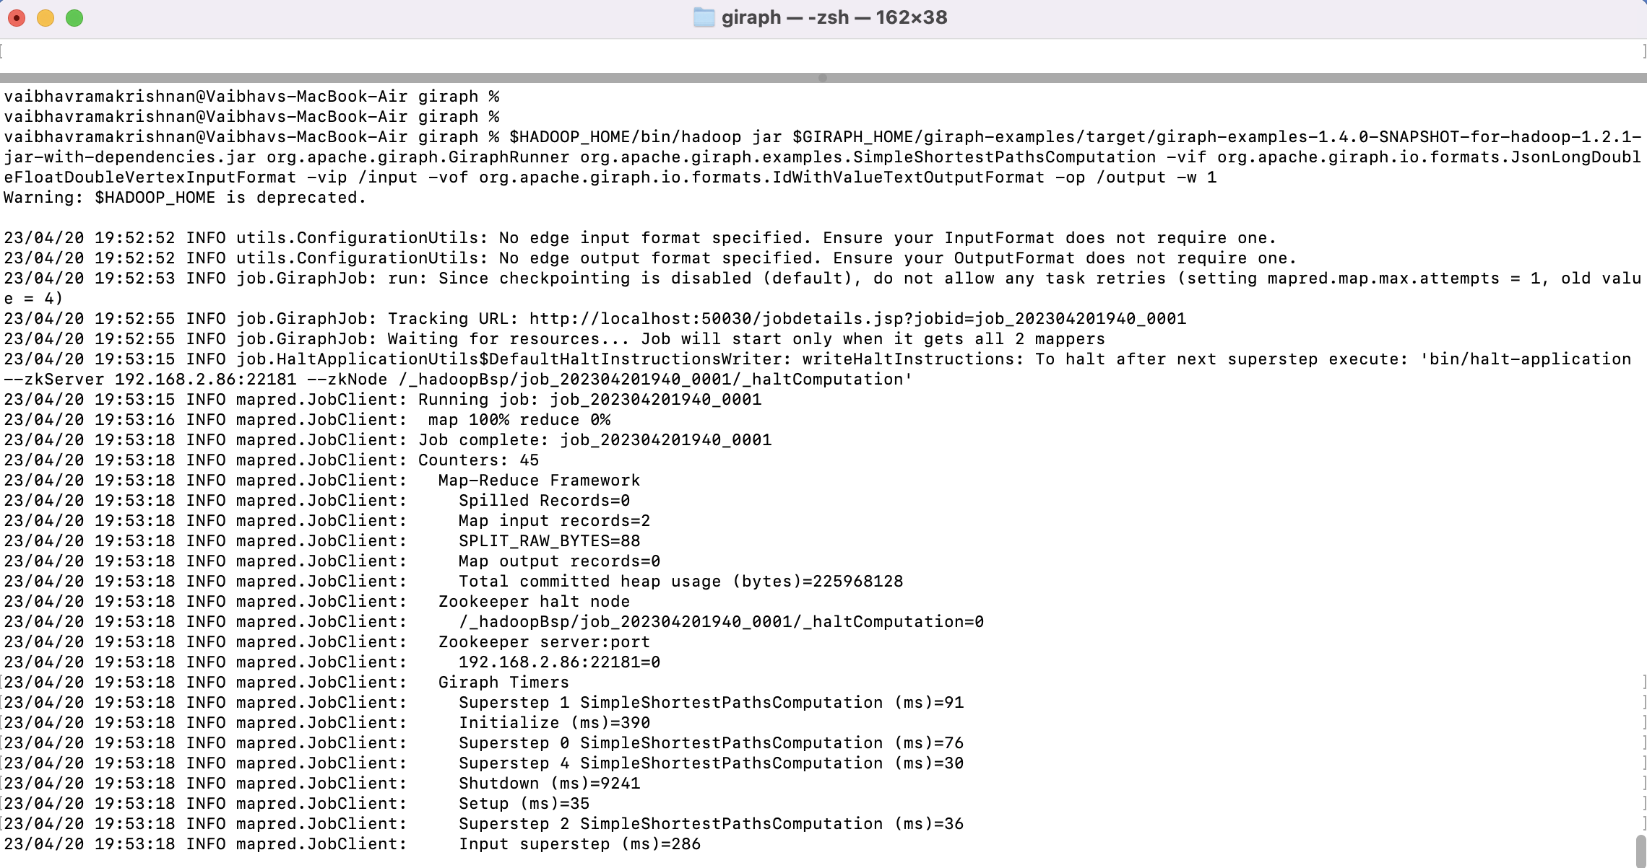

The below shows the output directories successfully created after running our Giraph job -

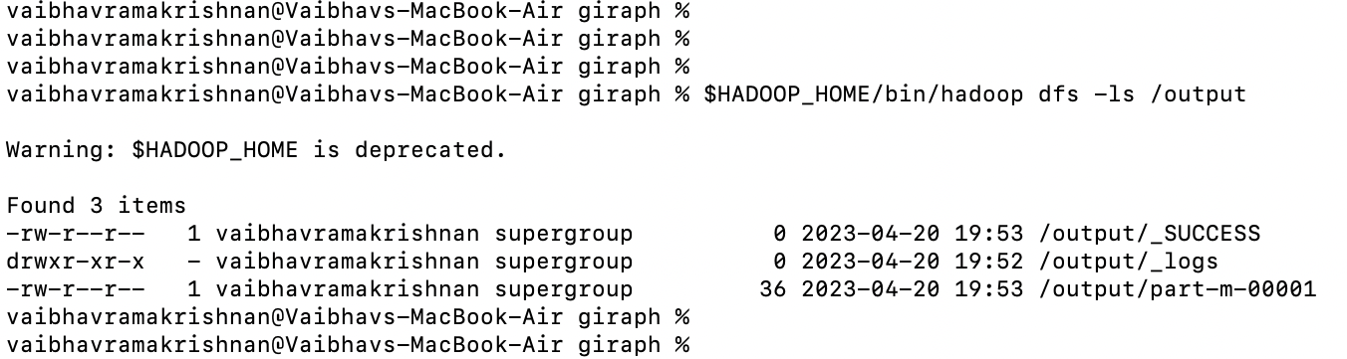

Then, we display the contents of the output file generated using the below command -

**$HADOOP_HOME/bin/hadoop dfs -cat /output/part-m-00001 | less**



# **4. Results**

The command we ran **$HADOOP_HOME/bin/hadoop dfs -cat /output/part-m-00001 | less** helped us print the contents of the file in the Hadoop system to the terminal.

The results have the following format -

Each line has a vertex ID, which is followed by the shortest distance value.

The vertex ID appears on the first line or column.

This reflects the order in which the cities on the TSP "tour" were visited. A tour is a route that begins in one place and visits each city once before returning to the starting point.

The entire distance of the TSP "tour" is shown in the second column. This means that a distance of 0.0 indicates that the city's start and finish points are the same.

The first vertex in this scenario has a distance of 0.0, which makes sense given that it is the starting point. This signifies that the tour begins and ends in city 1.

The additional cities are visited in the following order: 3,4,5, and 2.

The second city is 10221.0 units away, which is the total distance traversed for the entire algorithm or tour, as indicated in the output snapshot below -

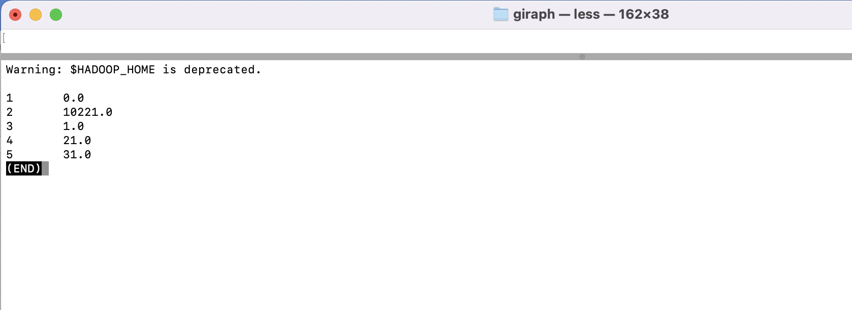

The result simply displays the shortest path from vertex 1 to each of the vertices. It does not display the actual route travelled or the shortest path. The shortest path, however, can be determined based on the sequence in which the vertices are visited.

For example, if we look at the output, we can see that the cities are visited in the following order: 1 -> 3 -> 4 -> 5 -> 2.

The shortest path from vertex 1 to vertex 2 is 10221 units.

The below snapshot, shows the health status of the HDFS cluster. This is the web interface of the HDFS NameNode. The below shows the number of files and directories in HDFS (28 total in our case), the amount of memory used by HDFS NameNode (17% in our case), capacity (228.27 GB), live nodes (1), etc.

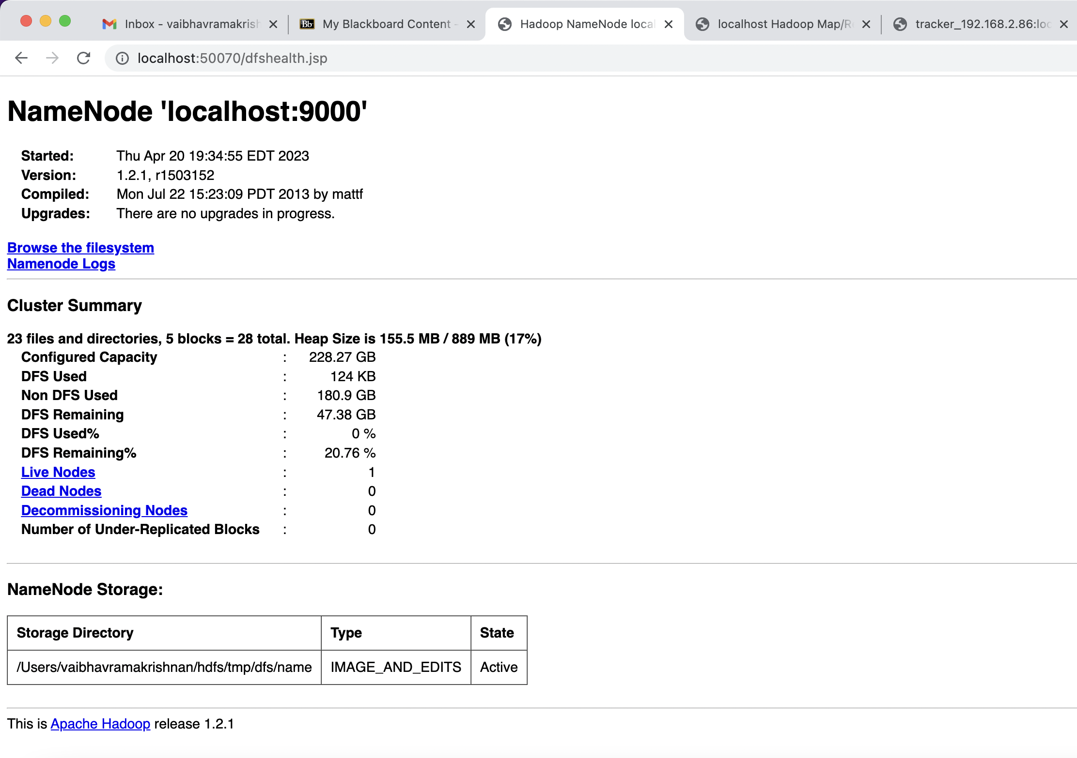

The below is the web interface for Hadoop MapReduce JobTracker.

The output below shows the status of our completed job, which include the name of our job In our case, the name is "Giraph:org.apache.giraph.examples.SimpleShortestPathsComputation"

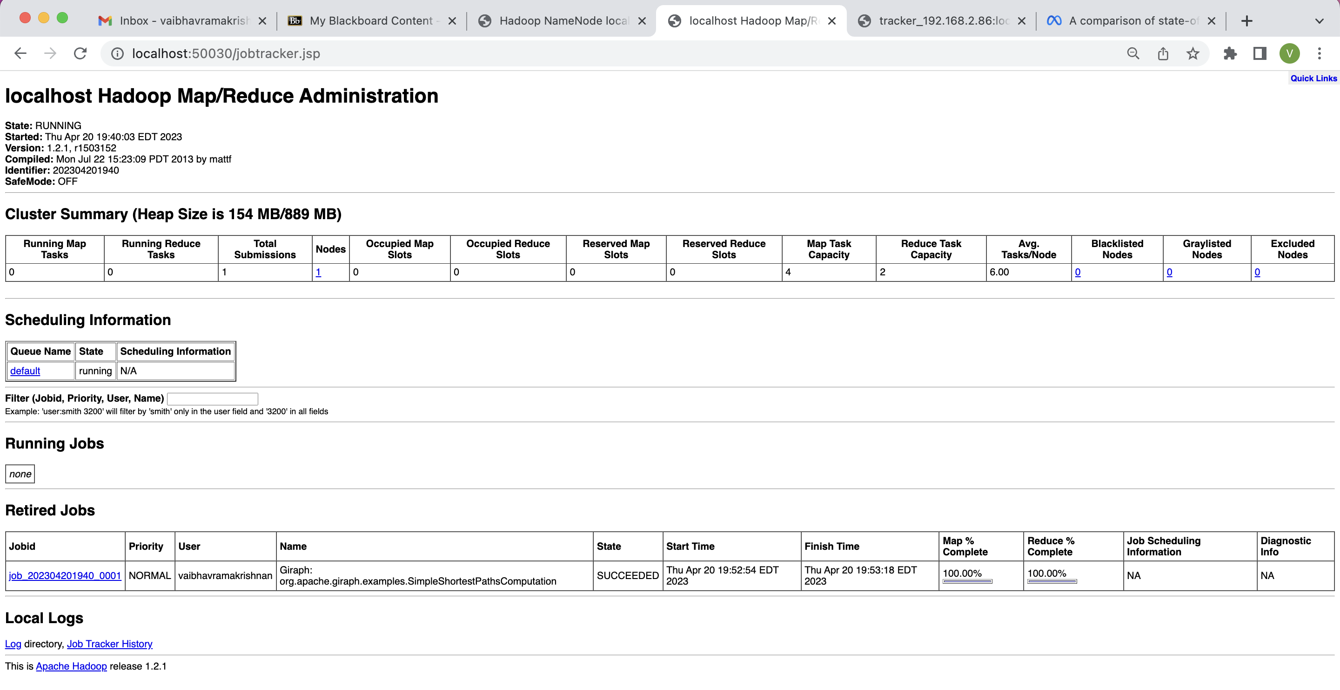

# **Discussion**

The findings presented above demonstrate that Apache Giraph was able to solve the TSP problem and discover the shortest path between cities with short runtimes. This is due to the distributed computing foundation of Apache Giraph, which allows us to process graphs on a huge scale in a distributed and parallelized manner. This yields in speedier computing times when compared to computations performed on a single machine.

## **5.1. Strengths and Limitations of Apache Giraph**

Giraph is used by LinkedIn and Facebook, demonstrating its capacity to manage dynamic graphs that evolve over time. This is significant since new connections are formed in social networks on a regular basis. This distinguishes Giraph from many other tools that are only intended for static graphs (for example, Neo4j and GraphX, which may not be as successful for managing dynamic graphs).

Giraph has the limitation of being memory-intensive. This can be difficult when dealing with large-scale graphs. Furthermore, Giraph is designed for batch processing, therefore it may not be the best choice for real-time applications where data must be processed in real-time. Furthermore, Giraph may necessitate a higher level of technical ability to operate efficiently as compared to other tools. This is because Giraph was introduced in 2011 and can be considered a little outdated, even if updated versions are produced in later years. This may be an issue for some people.

## **5.2 Comparison to other frameworks**

When comparing Giraph with GraphX, we can discuss the two systems' performance and ability to handle big graphs. We can also add their usability and ease of development in them.

### **5.2.1 Performance and Scalability**

* Giraph can process 50 times larges graphs than GraphX.
* Giraph performs better with smaller graphs as well.
* GraphX exhibits large performance variance, this means that the time it takes to execute a graph computation on a dataset can vary significantly.
* Giraph is more memory-efficient. The total memory needed to run jobs on a fixed graph size is lower than GraphX.
* This means Giraph requires fewer machine hours to process the same graph. This makes Giraph more efficient.

The Facebook engineering team (Kabiljo et al., 2018)conducted a performance comparison between GraphX and Giraph. Several graph processing algorithms were run on both systems and their runtime and scalability were evaluated. Among the algorithms studied were PageRank, Connected Components, and Triangle Counting.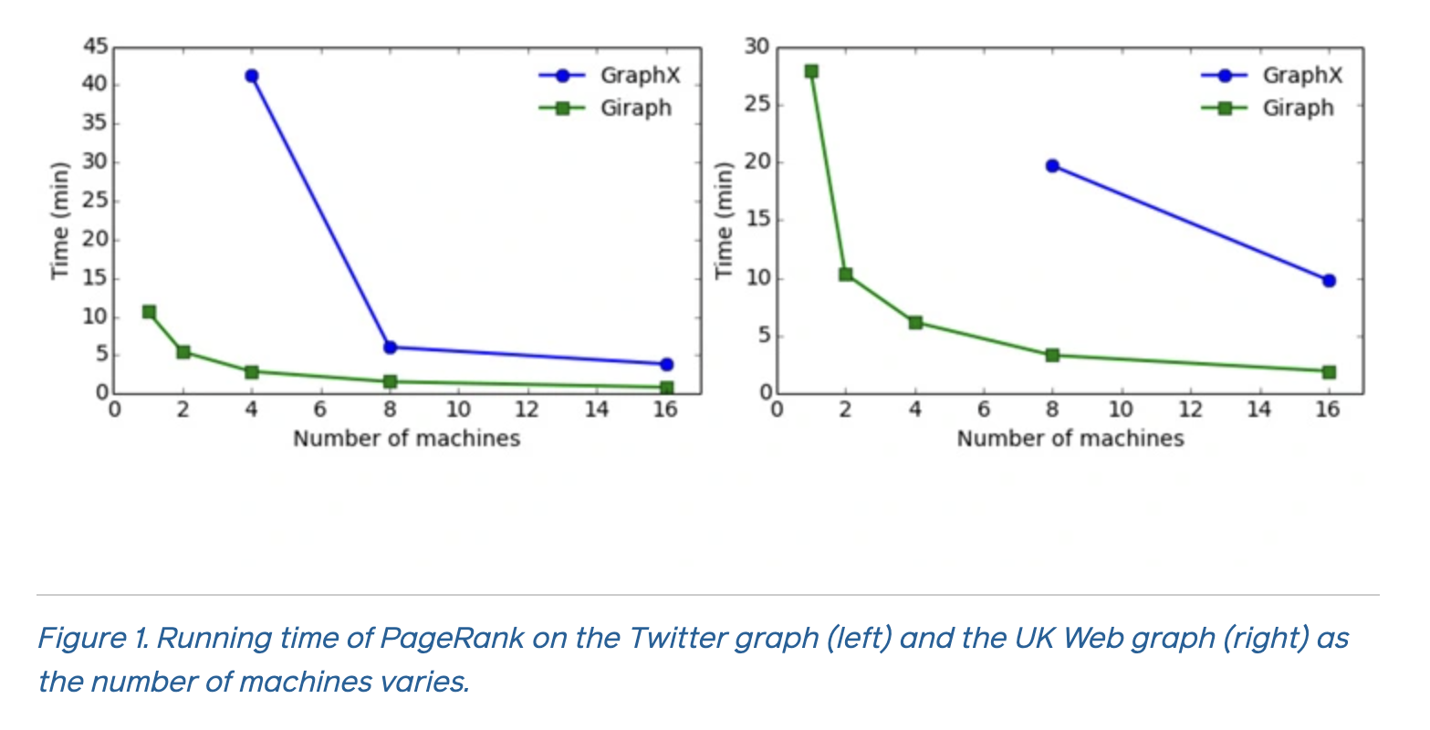

As shown above, Giraph can perform the PageRank algorithm on the Twitter graph 4.5 times quicker than GraphX with 16 workers and 4 times faster with eight workers.

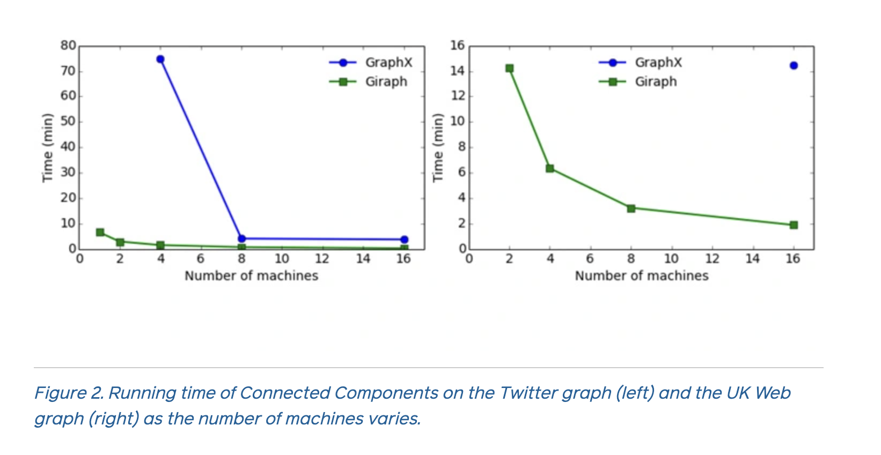

Giraph consumed 5.6 times less "machine time" than GraphX, according to the graph above. In the UK graph on the right, Giraph took 9x less machine time.

GraphX required 34 machine minutes (8 machines x 255 seconds), whereas Giraph required 6 machine minutes (2 machines x 186 seconds).

### **5.2.2 Usability and Application Development**

* GraphX allows users to read Hive graphs using SQL-like queries and conduct arbitrary column manipulations. This means that users may easily use data in Hive to generate a graph, however Giraph users must write additional code to pre-process the data and change it into Graph format in order for Giraph to recognise the format.
* Although an IDE is required for more complicated applications, using Scala in a shell environment is convenient for GraphX applications.

Overall, we observe that Giraph is better suited to handling production-scale workloads, whereas GraphX has a number of capabilities that make development easier.

# **Conclusion**

In this research, we investigated how to solve the Travelling Salesman Problem (TSP) using Apache Giraph, a distributed Graph processing system built on the Hadoop platform. We did the experiment on the Hadoop cluster using the Java programming language. The giraph (graph-format) input file contained a five-city graph with edge weights reflecting distances between the cities.

The findings (section 4) demonstrated that we were effective in implementing and solving the TSP and determining the shortest path between cities. The output supplied the shortest distances between the cities, as well as the route or order in which the cities should be visited. To put our findings into context, we found a comparison between Apache Giraph and GraphX and discovered that Giraph is considerably superior in terms of efficiency, execution speed, scalability, and working with large scale datasets or graph frameworks.

This project helped us discover the potential of Apache Giraph by efficiently solving complicated problems like TSP. This demonstrated how effective Apache Giraph is and why corporations such as Facebook and LinkedIn choose it over other frameworks such as GraphX for social network research, connection recommendations, and so on.

## **6.1 Challenges and Learnings from this Project**

The implementation of this project was riddled with obstacles. In 2012, Apache Giraph was published as an open-source graph processing tool. Given the rapid advances in Big Data, Apache Giraph provided countless innovations in this domain since then. Additionally, Giraph is still continuously maintained and updated with new releases. This made it difficult to discover new or updated reference materials or tutorial guides on YouTube to learn how to execute this. We had to rely on outdated recordings that were roughly 7 years old on average. As a result, we encountered compatibility issues with the most recent versions of Hadoop and Giraph, with some functionalities not supported by Giraph for the most recent versions of Hadoop. This meant we had to do a lot of digging to figure out which versions were compatible with each other. Finally, we discovered that Hadoop 1.2.1 was compatible with our Apache Giraph version (1.4). The next step was to locate an ancient version of Hadoop that was compatible with macOS, as most internet materials were only compatible with Linux-based systems. Once we resolved the compatibility issues and identified the appropriate Hadoop configuration parameters for our OS/Environment, we were able to properly execute our model.

**References**

Batarfi, O. et al. (2015). Large scale graph processing systems: survey and an experimental evaluation. SpringerLink. <http://link-springer-com.proxy1.lib.trentu.ca/content/pdf/10.1007/s10586-015-0472-6.pdf?pdf=button%20sticky>

Han, M. et al. (2014). An Experimental Comparison of Pregel-like Graph Processing Systems. <http://dl-acm-org.proxy1.lib.trentu.ca/doi/pdf/10.14778/2732977.2732980>

Koch, J. et al. (2016). An empirical comparison of Big Graph frameworks in the context of network analysis. SpringerLink. <http://link-springer-com.proxy1.lib.trentu.ca/article/10.1007/s13278-016-0394-1>

Maja Kabiljo, D. L. (2018, June 26). A comparison of state-of-the-art graph processing systems. Engineering at Meta. <https://engineering.fb.com/2016/10/19/core-data/a-comparison-of-state-of-the-art-graph-processing-systems/>

The Apache Software Foundation (2020). Apache Giraph. Project information. Apache Project Information. (n.d.). <http://projects.apache.org/project.html?giraph>

Arjun, C. W. (2023, March 7). Install hadoop on MACOS (M1, m2). Medium. <https://codewitharjun.medium.com/install-hadoop-on-macos-m1-m2-6f6a01820cc9>

<https://www.youtube.com/watch?v=inDC9jgwpWY>

Giraph travelling salesman example. Share and Discover Knowledge on SlideShare. (n.d.).<https://www.slideshare.net/EliasDaboussi/giraph-travelling-salesman-example-14127612>

Daboussi, E., Croisier, O., Staebler, C., &amp; Ouertani, S. (2012, August 30). Hadoop, part 3 : Graph processing with Giraph. Blog Zenika <https://blog.zenika.com/2012/08/30/giraph-graph-processing-with-hadoop-made-easy/>

Edaboussi. (n.d.). Edaboussi/Giraph: Giraph Brute-force implementation of the travelling salesman problem. GitHub. <https://github.com/edaboussi/Giraph>

<https://stackoverflow.com/questions/16713011/hadoop-namenode-is-not-starting-up>

<https://giraph.apache.org/releases.html>

marsty5. (2013, June 13). Run example in Giraph: PageRank. In a distributed manner... or not! Retrieved April 24, 2023, from <https://marsty5.wordpress.com/2013/05/29/run-example-in-giraph-pagerank/>

<https://www.youtube.com/watch?v=kq_Rt6hNvFE>

<https://www.youtube.com/watch?v=7n3xNHBc_gU>

<https://www.youtube.com/watch?v=en2nm1KKoOU>

<https://www.youtube.com/watch?v=FzR5zoEN9n8&t=781s>

<https://www.youtube.com/watch?v=PbEZxEdSo2A&t=453s>

**Appendix**

Below is the TSP.Java file code -

package giraph;

import com.google.common.base.Preconditions;

import com.google.common.collect.Maps;

import org.apache.giraph.comm.ArrayListWritable;

import org.apache.giraph.graph.BasicVertex;

import org.apache.giraph.graph.BspUtils;

import org.apache.giraph.graph.GiraphJob;

import org.apache.giraph.graph.EdgeListVertex;

import org.apache.giraph.graph.VertexReader;

import org.apache.giraph.graph.VertexWriter;

import org.apache.giraph.lib.TextVertexInputFormat;

import org.apache.giraph.lib.TextVertexInputFormat.TextVertexReader;

import org.apache.giraph.lib.TextVertexOutputFormat;

import org.apache.giraph.lib.TextVertexOutputFormat.TextVertexWriter;

import org.apache.hadoop.conf.Configuration;

import org.apache.hadoop.fs.Path;

import org.apache.hadoop.io.DoubleWritable;

import org.apache.hadoop.io.FloatWritable;

import org.apache.hadoop.io.IntWritable;

import org.apache.hadoop.io.LongWritable;

import org.apache.hadoop.io.Text;

import org.apache.hadoop.mapreduce.InputSplit;

import org.apache.hadoop.mapreduce.RecordReader;

import org.apache.hadoop.mapreduce.RecordWriter;

import org.apache.hadoop.mapreduce.TaskAttemptContext;

import org.apache.hadoop.mapreduce.lib.input.FileInputFormat;

import org.apache.hadoop.mapreduce.lib.output.FileOutputFormat;

import org.apache.hadoop.util.Tool;

import org.apache.hadoop.util.ToolRunner;

import org.apache.log4j.Logger;

import org.json.JSONArray;

import org.json.JSONException;

import java.io.IOException;

import java.util.ArrayList;

import java.util.Iterator;

import java.util.Map;

import java.util.StringTokenizer;

/**

* Shows an example of a brute-force implementation of the Travelling Salesman Problem

*/

public class TSP extends

EdgeListVertex<LongWritable, ArrayListWritable<DoubleWritable>,

FloatWritable, ArrayListWritable<Text>> implements Tool {

/** Configuration */

private Configuration conf;

/** Class logger */

private static final Logger LOG =

Logger.getLogger(TSP.class);

/** The shortest paths id */

public static String SOURCE_ID = "SimpleShortestPathsVertex.sourceId";

/** Default shortest paths id */

public static long SOURCE_ID_DEFAULT = 1;

/**

* Is this vertex the source id?

*

* @return True if the source id

*/

private boolean isSource() {

return (getVertexId().get() ==

getContext().getConfiguration().getLong(SOURCE_ID,

SOURCE_ID_DEFAULT));

}

public class Message extends ArrayListWritable<Text> {

public Message() {

super();

}

@Override

public void setClass() {

// TODO Auto-generated method stub

}

}

public class Valeur extends ArrayListWritable<DoubleWritable> {

public Valeur() {

super();

}

@Override

public void setClass() {

// TODO Auto-generated method stub

}

}

@Override

public void compute(Iterator<ArrayListWritable<Text>> msgIterator) {

System.out.println("**** LAUNCHING COMPUTATION FOR VERTEX "+this.getVertexId().get()+", SUPERSTEP "+this.getSuperstep()+" ****");

//We get the source ID, we will need it

String sourceID = new LongWritable(this.getContext().getConfiguration().getLong(SOURCE_ID,

SOURCE_ID_DEFAULT)).toString();

//We get the total number of verticles, and the current superstep number, we will need it too

int J=1;

for (LongWritable targetVertexId : this) {

J++;

}

final int N=J;

long k=this.getSuperstep();

/**

* COLLECTING OF THE PREVIOUS MESSAGES :

* We need to collect the previous superstep's messages :

* the positive numbers will go to the distance list, and the negative ones will go to the path list

*/

//we first collect all messages in one list, each message is a pair (path,cost)

ArrayList<ArrayListWritable<Text>> messages=new ArrayList<ArrayListWritable<Text>>();

ArrayList<IntWritable> idList=new ArrayList<IntWritable>();

ArrayList<DoubleWritable> distList=new ArrayList<DoubleWritable>();

//we then fill the two lists : the path list and the distance list

while (msgIterator.hasNext()){

ArrayListWritable<Text> message = msgIterator.next();

messages.add(message);

idList.add(new IntWritable(Integer.parseInt(message.get(0).toString())));

System.out.println("Adding the path "+message.get(0).toString()+" to the paths list");

distList.add(new DoubleWritable(Double.parseDouble(message.get(1).toString())));

System.out.println("Adding the distance "+message.get(1).toString()+" to the distance list");

}

/**

* SUPERSTEP 0

*/

if(k==0){

System.out.println("SUPERSTEP 0");

//Superstep 0 : we send only from the source vertex

if(this.isSource()){

for (LongWritable targetVertexId : this) {

Message msg=new Message();

String trajetIni=this.getVertexId().toString();

//we create the message

msg.add(new Text(trajetIni));

msg.add(new Text(this.getEdgeValue(targetVertexId).toString()));

//we actually send the message

this.sendMsg(targetVertexId,msg);

System.out.println("sending the message "+msg.toString()+" to the vertex "+targetVertexId.toString());

Valeur valeur = new Valeur();

valeur.add(new DoubleWritable(0));

this.setVertexValue(valeur);

}

}

else{

System.out.println("Nothing to do during this superstep : this vertex is not the source vertex");

}

System.out.println("END OF SUPERSTEP 0");

}

/**

* NORMAL SUPERSTEP>0

*/

if((k<N-1 && k>0) || k==1){

System.out.println("NORMAL SUPERSTEP "+this.getSuperstep());

//we will process the received messages one by one

int index = 0;//the current message number (for the distance and the path)

String path=sourceID;

for (DoubleWritable message : distList){

//we can only send messages to vertex that are not already in the path, so

//we have to know which vertexs are already in the paths

path=idList.get(index).toString();

ArrayList liste = new ArrayList();

StringTokenizer tokens = new StringTokenizer(path,"");

while(tokens.hasMoreTokens()){

liste.add(tokens.nextElement());

}

ArrayList<String> listeString=new ArrayList<String>();

for(Object token:liste){

listeString.add(token.toString());

}

//we can now process all edges and send to the target vertex only if it is not in the path already:

for (LongWritable targetVertexId : this) {

System.out.println("We will now try to send a message to the vertex "+targetVertexId.toString()+" , here is a list of the vertex already done : ");

boolean isAlreadyInThePath=false;

for(String vertex:listeString){

if(vertex.contains(targetVertexId.toString())){

isAlreadyInThePath=true;

}

}

if(isAlreadyInThePath==true){

System.out.println("This vertex "+targetVertexId.toString()+" is already in the path : "+listeString);

}

if(isAlreadyInThePath==false){

//we can send the two messages to this target vertex : the new distance (positive) and the new path (negative)

Message msg = new Message();

//first message : the new distance cost

int dist=(int) Math.floor(Double.parseDouble(message.toString()));

float value = dist+this.getEdgeValue(targetVertexId).get();

String newPath = path+this.getVertexId().toString();

msg.add(new Text(newPath));

msg.add(new Text(String.valueOf(value)));

this.sendMsg(targetVertexId,msg);

System.out.println("We send the message "+msg.toString()+"to the vertex "+targetVertexId.toString());

}

}

index++;

}

System.out.println("END OF SUPERSTEP "+k);

}

/**

* LAST SUPERSTEP BUT ONE :

* At the last superstep but one, we send all the messages to the source vertex

*/

if(k==N-1 && k>1){

System.out.println("SUPERSTEP N-1");

if(this.getVertexId().toString().equals(sourceID)){

System.out.println("This is the source vertex, this message should not appear");

}

else{

int index2 = 0;//the current message's index

String newPath=sourceID;

for (DoubleWritable message : distList){

newPath=idList.get(index2).toString();

LongWritable sourceIDLongWritable= new LongWritable(Long.parseLong(sourceID));

Message msg=new Message();

//first message : the new distance cost

double dist=Double.parseDouble(message.toString());

double value = dist+this.getEdgeValue(sourceIDLongWritable).get();

newPath=newPath+this.getVertexId().toString();

msg.add(new Text(newPath));

msg.add(new Text(String.valueOf(value)));

this.sendMsg(sourceIDLongWritable,msg);

System.out.println("We send the path "+msg.toString()+" to the vertex "+sourceIDLongWritable.toString());

index2++;

}

}

System.out.println("END OF SUPERSTEP N-1");

}

/**

* LAST SUPERSTEP :

* The source vertex retrieves all the possible paths, and can then find the shortest

*/

if(k==N && k>1 && this.getVertexId().toString().equals(sourceID)){

System.out.println("LAST SUPERSTEP");

//we look for the minimu distance cost among the distance messages, and also take the corresponding path

double minDist = Double.MAX_VALUE;

int index3 = 0;

int finalIndex=0;

for(DoubleWritable message : distList){

double valeurDuMessage = Double.parseDouble(message.toString());

if(minDist>valeurDuMessage){

minDist=valeurDuMessage;

finalIndex=index3;

}

index3++;

}

//we can then access the shortest Path

String finalPath="";

finalPath=idList.get(finalIndex).toString()+sourceID;

DoubleWritable idFinal = new DoubleWritable(Double.parseDouble(finalPath));

Valeur valeur = new Valeur();

valeur.add(idFinal);

valeur.add(new DoubleWritable(minDist));

this.setVertexValue(valeur);

System.out.println("The shortest path is "+finalPath+" , costing "+minDist);

System.out.println("END OF THE LAST SUPERSTEP");

}

System.out.println("*** END OF THE SUPERSTEP "+k+" FOR THE VERTEX "+this.getVertexId().toString()+" VOTES TO HALT *****");

voteToHalt();

}

/**

* VertexInputFormat that supports {@link TSP}

*/

public static class SimpleShortestPathsVertexInputFormat extends

TextVertexInputFormat<LongWritable,

ArrayListWritable<DoubleWritable>,

FloatWritable,

DoubleWritable> {

@Override

public VertexReader<LongWritable, ArrayListWritable<DoubleWritable>, FloatWritable, DoubleWritable>

createVertexReader(InputSplit split,

TaskAttemptContext context)

throws IOException {

return new SimpleShortestPathsVertexReader(

textInputFormat.createRecordReader(split, context));

}

}

/**

* VertexReader that supports {@link TSP}. In this

* case, the edge values are not used. The files should be in the

* following JSON format:

* JSONArray(<vertex id>, <vertex value>,

* JSONArray(JSONArray(<dest vertex id>, <edge value>), ...))

* Here is an example with vertex id 1, vertex value 4.3, and two edges.

* First edge has a destination vertex 2, edge value 2.1.

* Second edge has a destination vertex 3, edge value 0.7.

* [1,4.3,[[2,2.1],[3,0.7]]]

*/

public static class SimpleShortestPathsVertexReader extends

TextVertexReader<LongWritable,

ArrayListWritable<DoubleWritable>, FloatWritable, DoubleWritable> {

public SimpleShortestPathsVertexReader(

RecordReader<LongWritable, Text> lineRecordReader) {

super(lineRecordReader);

}

public class Valeur extends ArrayListWritable<DoubleWritable> {

public Valeur() {

super();

}

@Override

public void setClass() {

// TODO Auto-generated method stub

}

}

@Override

public BasicVertex<LongWritable, ArrayListWritable<DoubleWritable>, FloatWritable,

DoubleWritable> getCurrentVertex()

throws IOException, InterruptedException {

BasicVertex<LongWritable, ArrayListWritable<DoubleWritable>, FloatWritable,

DoubleWritable> vertex = BspUtils.<LongWritable, ArrayListWritable<DoubleWritable>, FloatWritable,

DoubleWritable>createVertex(getContext().getConfiguration());

Text line = getRecordReader().getCurrentValue();

try {

JSONArray jsonVertex = new JSONArray(line.toString());

LongWritable vertexId = new LongWritable(jsonVertex.getLong(0));

Valeur vertexValue = new Valeur();

vertexValue.add(new DoubleWritable(jsonVertex.getDouble(1)));

Map<LongWritable, FloatWritable> edges = Maps.newHashMap();

JSONArray jsonEdgeArray = jsonVertex.getJSONArray(2);

for (int i = 0; i < jsonEdgeArray.length(); ++i) {

JSONArray jsonEdge = jsonEdgeArray.getJSONArray(i);

edges.put(new LongWritable(jsonEdge.getLong(0)),

new FloatWritable((float) jsonEdge.getDouble(1)));

}

vertex.initialize(vertexId, vertexValue, edges, null);

} catch (JSONException e) {

throw new IllegalArgumentException(

"next: Couldn't get vertex from line " + line.toString(), e);

}

return vertex;

}

@Override

public boolean nextVertex() throws IOException, InterruptedException {

return getRecordReader().nextKeyValue();

}

}

/**

* VertexOutputFormat that supports {@link TSP}

*/

public static class SimpleShortestPathsVertexOutputFormat extends

TextVertexOutputFormat<LongWritable, ArrayListWritable<DoubleWritable>,

FloatWritable> {

@Override

public VertexWriter<LongWritable, ArrayListWritable<DoubleWritable>, FloatWritable>

createVertexWriter(TaskAttemptContext context)

throws IOException, InterruptedException {

RecordWriter<Text, Text> recordWriter =

textOutputFormat.getRecordWriter(context);

return new SimpleShortestPathsVertexWriter(recordWriter);

}

}

/**

* VertexWriter that supports {@link TSP}

*/

public static class SimpleShortestPathsVertexWriter extends

TextVertexWriter<LongWritable, ArrayListWritable<DoubleWritable>, FloatWritable> {

public SimpleShortestPathsVertexWriter(

RecordWriter<Text, Text> lineRecordWriter) {

super(lineRecordWriter);

}

@Override

public void writeVertex(BasicVertex<LongWritable, ArrayListWritable<DoubleWritable>,

FloatWritable, ?> vertex)

throws IOException, InterruptedException {

String sourceID = new LongWritable(vertex.getContext().getConfiguration().getLong(SOURCE_ID,

SOURCE_ID_DEFAULT)).toString();

JSONArray jsonVertex = new JSONArray();

try {

jsonVertex.put(vertex.getVertexId().get());

jsonVertex.put(vertex.getVertexValue().toString());

JSONArray jsonEdgeArray = new JSONArray();

for (LongWritable targetVertexId : vertex) {

JSONArray jsonEdge = new JSONArray();

jsonEdge.put(targetVertexId.get());

jsonEdge.put(vertex.getEdgeValue(targetVertexId).get());

jsonEdgeArray.put(jsonEdge);

}

jsonVertex.put(jsonEdgeArray);

} catch (JSONException e) {

throw new IllegalArgumentException(

"writeVertex: Couldn't write vertex " + vertex);

}

getRecordWriter().write(new Text(jsonVertex.toString()), null);

}

}

@Override

public Configuration getConf() {

return conf;

}

@Override

public void setConf(Configuration conf) {

this.conf = conf;

}

@Override

public int run(String[] argArray) throws Exception {

Preconditions.checkArgument(argArray.length == 4,

"run: Must have 4 arguments <input path> <output path> " +

"<source vertex id> <# of workers>");

GiraphJob job = new GiraphJob(getConf(), getClass().getName());

job.setVertexClass(getClass());

job.setVertexInputFormatClass(

SimpleShortestPathsVertexInputFormat.class);

job.setVertexOutputFormatClass(

SimpleShortestPathsVertexOutputFormat.class);

FileInputFormat.addInputPath(job, new Path(argArray[0]));

FileOutputFormat.setOutputPath(job, new Path(argArray[1]));

job.getConfiguration().setLong(TSP.SOURCE_ID,

Long.parseLong(argArray[2]));

job.setWorkerConfiguration(Integer.parseInt(argArray[3]),

Integer.parseInt(argArray[3]),

100.0f);

return job.run(true) ? 0 : -1;

}

public static void main(String[] args) throws Exception {

System.exit(ToolRunner.run(new TSP(), args));

}

}

Below is the **tiny_graph** file contents –

[1,0,[[2,10000000],[3,1],[4,100],[5,1200]]]

[2,0,[[1,1100],[3,1100000],[4,110],[5,1200]]]

[3,0,[[1,12],[4,20],[2,12000],[5,120]]]

[4,0,[[1,120],[3,1200],[2,10200],[5,10]]]]

[5,0,[[1,1],[3,1200],[2,10200],[4,120]]]